***LAKME 224***

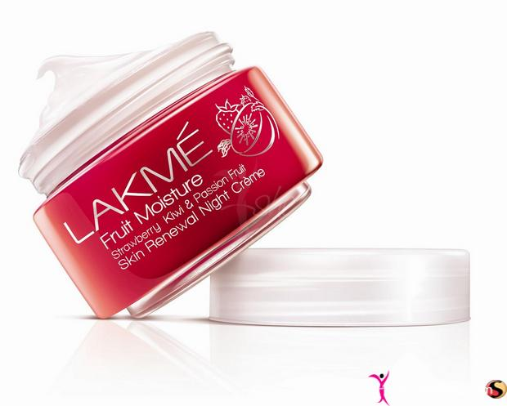

***DESCRIPTION:***

**LAKME’S WHITENING CREAM CONTAINS 100% GOAT MILK IN COMBINATION WITH NEW REVOLUTIONARY WHITENING BEADS.THE NATURAL VITAMINS IN GOAT MILK PROVIDE INSTANT NOURISHMENT TO THE SKIN,MAKING IT SOFT,SMOOTH AND GLOWING.WHILE THE WHITENING BEADS CONTAINING TYROSINASE INHIBITORS GENTLY DISSOLVE IN THE SKIN TO MAKE IT NOTICEABLY FAIRER IN JUST TWO WEEKS.**